* **Lab Task 1**

Write a SQL statement that uses a subquery to display the last name and hire date of any employee in the same department as the employee whose last name is provided by the user.

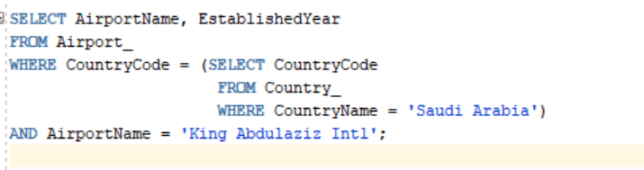

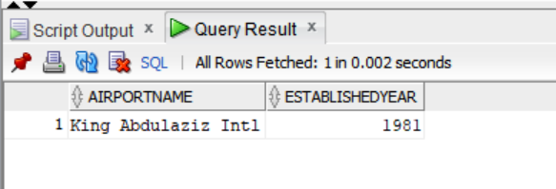OUTPUT: